**5 Back-up Windows Software**

1. DirSync (Directory Synchronize Pro)
   1. About

DirSync Pro is a small, but powerful utility for file and folder synchronization. DirSync Pro can be used to synchronize the content of one or many folders recursively. Use DirSync Pro to easily synchronize files from your desktop PC to your USB-stick (/Externa HD/PDA/Notebook, ...). Use this USB-stick (/Externa HD/PDA/Notebook, ...) to synchronize files to another desktop PC.

* 1. Features
* Synchronization
  + Powerful synchronization algorithm.
  + Bi-directional (Two way) and mono-directional (One way) synchronization mode.
  + Predefined synchronization modes for mostly used synchronizations
  + More on their website.
* Schedule Engine
  + DirSync Pro has a powerful Schedule Engine with lots of features to run automated scheduled synchronization tasks.
* Filters
  + DirSync Pro has comprehensive filters to include or exclude files and directories.
* General
  + Easy, clear and user-friendly graphical user interface, no unnecessary gadget you never use.
  + It is Portable! It does not need any installation. Just run the application!
  + Open source, it is 100% free of charge, 100% free of commercial text, 100% free of advertisements and 100% free of spyware.
* Logging
  + Advanced logging/reporting facilities. Just select a log level and define where to write the log.
  + Option to log on application level (default log)
  + Option to log on each directory level (dir log)
  + Option to define the log leven (how much to log)
  1. Reviews

“Very good free program when you got much files to have a back-up. Secure and much possibilities. Also the message-tab is very easy to have a nice summary of all the work the program will do after the analyzation of your files. Redundant files are deleted without problem, so you don't have to delete them manually. Possibility to choose what you want to see in your synchronization queue like new or modified directories or files, conflicts, dir. or files to be deleted.” – CNET

1. Create Synchronicity  
   1. About

Create Synchronicity is a powerful and lightweight open source backup and synchronization program, available in many languages. Create Synchronicity is a backup/synchronization tool that can help you protect your files, and keep your data up-to-date. You can use it for pretty much everything from copying your documents, pictures, music and videos to your USB Key or backup drive, to scheduling server backups with regex filtering and DST compensation.

* 1. Features
* Fully customizable synchronization and backup
* Full scheduling support (daily, weekly, monthly, at a particular time, etc.)
* Catching up: automatically reschedule missed backups
* Clean, simple interface
* More on their official website
* Comprehensive previews
* Comprehensive, pretty logs.
* Support for multiple profiles
  1. Reviews

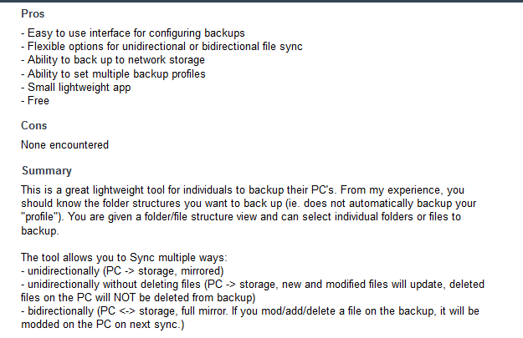

1. AOMEI Backupper
   1. About

AOMEI Backupper Professional is a complete and reliable PC backup, restore and clone software for any version of Windows 10, Windows 8.1, Windows 8, Windows 7, Vista, and XP.

It supports system/files/folders/disk/partition backup, restore and clone as well as provides other advanced features, such as backup using command line prompt or batch scripts, automatically delete older backup images to manage backup disk space, merge multiple incremental backups into a full backup, file sync, schedule/incremental/differential backup, backup to NAS/network, partition alignment to optimize SSD during the restoring or cloning operation, dynamic disk volumes backup, GPT disk backup, create Windows PE & Linux bootable media, manually add additional drivers when create Windows PE Bootable CD, sending e-mail notifications, backing up or restoring files from a network to another, editing task name and the directory of backup images, backup logs management, exporting or importing all backup tasks, start up multiple client machines within LAN through the PXE network booting by using AOMEI Windows PE and Linux micro-system or your own personalized bootable image file on a master machine for system maintenance and so on.

Besides, the unique function of this program is universal restore, which enables you to recover or migrate a system to physical or virtual machines with dissimilar/different hardware. Another highlight is VSS, a technology from Microsoft that enables system and data backup processes won't be interrupted by running applications. So it is very efficient because backup can still be available when you're working.

* 1. Features
     + Complete Backup
       - System Backup
       - Disk Backup
       - File/Folder Backup and Sync Partition Backup
       - Schedule Automatic Backup
       - Incremental Backup
       - Differential Backup
       - Backup to NAS/Network
     + Fast Restore
       - System Restore
       - Disk Restore
       - File/Folder Restore
       - Select File Restore
       - Partition Restore
       - Universal Restore
       - UEFI Restore
       - Restore by Sector Alignment
     + Easy Clone
       - Disk Clone
       - System Clone (AOMEI Backupper Standard need to unlock)
       - Partition Clone
       - Clone with Resize
       - Clone by Sector Alignment
     + Powerful Utilities
       - Create Bootable Media
       - Check Image
       - Explore Image
       - Compress Image
       - Encrypt Backup PXE Boot Tool (AOMEI Backupper Standard can only boot for 3 client-side computers)
     + Supported Technologies
       - Support 4K monitor
       - Support UEFI/EFI boot mode
       - Support NTFS/FAT/EXT file system
       - Support MBR disk, GPT disk and dynamic disk Support internal disk, external hard drive, USB flash drive, SSD, Hardware RAID, NAS, Virtual devices, etc.
     + Support Windows 10/8.1/8/7/Vista/XP
     + License Type: Freeware
  2. Reviews

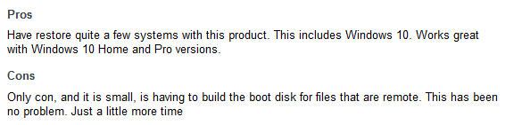

1. LuckyBackup
   1. About

[LuckyBackup](http://luckybackup.sourceforge.net/) is a powerful, fast and reliable backup & sync tool. he current status of the port can be summed up with something like, “It mostly works and there is active development to improve it.” The Windows version of luckyBackup is not however 100% functional and there are known (and probably unknown) glitches and bugs with it. Please if you find any problems report them back to us so that we can get them resolved and make luckyBackup just as fantastic on Windows as it already is on Linux.

A side note! I'm brand new at using Qt and C++ is pretty sketchy for me since I haven't used C in years. So the “active development” means, a slow but steady progress.

* 1. Features
     + Backup
     + Snapshots
     + Sync
     + Simple/Advance Option
     + Exclude Option
     + Only include Option
     + Remote Connections
     + Also execute
     + Simulation
     + Include option-Execution order
     + Profiles
     + Scheduling
     + E-mail
     + Logfile
     + Command line mode
     + Tray Notification
  2. Reviews

1. FullSync
   1. About

FullSync is a universal file synchronization and backup tool which is highly customizable and expandable. It is especially for developers, but the basic functionality is easy enough for everyone. FullSync is a powerful tool that helps you keep multiple copies of various data in sync. I.e. it can update your Website using (S)Ftp, backup your data or refresh a working copy from a remote server. It offers flexible rules, a scheduler and more

* 1. Features
     + Publication and update of websites, synchronization of local directories and making backups of your data.
     + Configuration and rule-rewriting per directory possible.
     + Flexible rules, allowing all kinds of exclusion/inclusion.
     + Multiple protocols supported FTP, SFTP, SMB/CIFS(Windows Shares) and of course local files.
     + Scheduled execution of synchronizations using intervals or a crontab like scheduling.
     + Ability to remotely control a FullSync instance running on another computer.
  2. Reviews

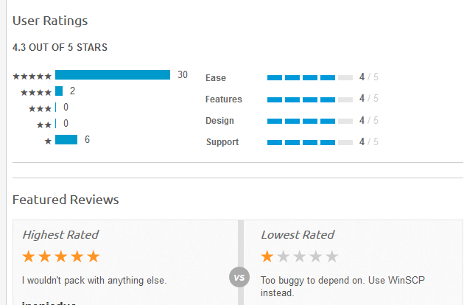

|  |  |  |  |  |  |
| --- | --- | --- | --- | --- | --- |
| Software | Features | System Specification | Remarks | License Type |  |
| DirSyncPro | * Synchronization   + Powerful synchronization algorithm.   + Bi-directional (Two way) and mono-directional (One way) synchronization mode.   + Predefined synchronization modes for mostly used synchronizations   + More on their website. * Schedule Engine   + DirSync Pro has a powerful Schedule Engine with lots of features to run automated scheduled synchronization tasks. * Filters   + DirSync Pro has comprehensive filters to include or exclude files and directories. * General   + Easy, clear and user-friendly graphical user interface, no unnecessary gadget you never use.   + It is Portable! It does not need any installation. Just run the application!   + Open source, it is 100% free of charge, 100% free of commercial text, 100% free of advertisements and 100% free of spyware. * Logging   + Advanced logging/reporting facilities. Just select a log level and define where to write the log.   + Option to log on application level (default log)   + Option to log on each directory level (dir log)   + Option to define the log leven (how much to log) |  | Based on how I used the application, it can back-up and mirrored my documents in a low of minutes. It also has specific source and destination where I can get and put my data. The duration of backing up or mirroring the data is depending on how large the data is. It’s a good application to use to back-up or mirrored the data. There is a choice where you want to mirrored that data or the data on the destination will remain and it will just copy the content of the source data. | Open Source |  |
| Create Synchronization | * Fully customizable synchronization and backup * Full scheduling support (daily, weekly, monthly, at a particular time, etc.) * Catching up: automatically reschedule missed backups * Clean, simple interface * More on their official website * Comprehensive previews * Comprehensive, pretty logs. * Support for multiple profiles |  | Based on how I used this application, it was a good application. It also has sour and destination where I can get and put the data of a specific path where I can easily find where I put my backed-up data. It take minutes to back-up the data. | Open Source |  |
| AOMEI Backupper | * + - Complete Backup       * System Backup       * Disk Backup       * File/Folder Backup and Sync Partition Backup       * Schedule Automatic Backup       * Incremental Backup       * Differential Backup       * Backup to NAS/Network     - Fast Restore       * System Restore       * Disk Restore       * File/Folder Restore       * Select File Restore       * Partition Restore       * Universal Restore       * UEFI Restore       * Restore by Sector Alignment     - Easy Clone       * Disk Clone       * System Clone (AOMEI Backupper Standard need to unlock)       * Partition Clone       * Clone with Resize       * Clone by Sector Alignment     - Powerful Utilities       * Create Bootable Media       * Check Image       * Explore Image       * Compress Image       * Encrypt Backup PXE Boot Tool (AOMEI Backupper Standard can only boot for 3 client-side computers)     - Supported Technologies       * Support 4K monitor       * Support UEFI/EFI boot mode       * Support NTFS/FAT/EXT file system       * Support MBR disk, GPT disk and dynamic disk Support internal disk, external hard drive, USB flash drive, SSD, Hardware RAID, NAS, Virtual devices, etc.     - Support Windows 10/8.1/8/7/Vista/XP     - License Type: Freeware |  | For me it is good app you can restore your files that you deleted and it is easy to use no more such many thing to consider just you read and click and you can restore or back up your own files at ease and it is very fast when it comes to functionality it comes that if you purchase this app in their site their offer many free lifetime for an free time of purchase so rather had a copy or download it for free in other site for just a opinion if you want to download this app. | Freeware |  |
| LuckyBackup | * + - Backup     - Snapshots     - Sync     - Simple/Advance Option     - Exclude Option     - Only include Option     - Remote Connections     - Also execute     - Simulation     - Include option-Execution order     - Profiles     - Scheduling     - E-mail     - Logfile     - Command line mode     - Tray Notification |  | This application is simple and easy to use, it is a direct application where also has source and destination. | Open Source |  |
| FullSync | * + - Publication and update of websites, synchronization of local directories and making backups of your data.     - Configuration and rule-rewriting per directory possible.     - Flexible rules, allowing all kinds of exclusion/inclusion.     - Multiple protocols supported FTP, SFTP, SMB/CIFS(Windows Shares) and of course local files.     - Scheduled execution of synchronizations using intervals or a crontab like scheduling.     - Ability to remotely control a FullSync instance running on another computer. |  | This application is small yet simple back-up software where can easily back-up your data by putting the source of the data and destination where you can put your data. | Open Source |  |

So basically, the bunch of software were good enough to use to back-up or mirrored the data you have. On a bunch of back-up software above there, they all have the same function on how they back-up and mirrored the data. The good on them is, they are open source application where I can check the algorithms of backing-up the data, transferring to another destination and mirroring on it. This may help us to start our application on backing up. On innovating these software, we would like to use the real-time as not all of the user are usually backing up there data, some are lazy or some just ignoring it. So our team wants to implement the real-time back-up to keep the data safe.